**HEALTHCARE WEB**

# A PROJECT REPORT

***Submitted by***

# K. HARISH

***in partial fulfilment for the award of the degree*** ***of***

# BACHELOR OF TECNOLOGY

**IN**

**COMPUTER SCIENCE AND ENGINEERING**

**SPECIALIZATION IN ARTIFICIAL INTELLIGENCE AND MACHINE**

## LEARNING



# Lovely Professional University, Punjab

**OCTOBER 2024**

**Lovely Professional University, Punjab**

# BONAFIDE CERTIFICATE

Certified that this project report **“……HEALTHCARE WEB………”**

## is the bonafide work of “…. K. HARISH …...”

who carried out the project work under my supervision.

**SIGNATURE**

**Dr. Jaibir Singh**

**ABSTRACT-**

### Health Care web

### Project Overview:

The "Health Care" website is designed as a comprehensive platform to provide users with accessible and reliable information about health and wellness. This project focuses on delivering an intuitive user experience through clear navigation, responsive design, and informative content on topics such as preventive care, healthy lifestyle tips, and common health concerns.

### Project Objectives:

### To connect people to healthcare facilities. Encourage users to engage with content focused on preventive care, healthy living, and common medical concerns to support proactive health management. Encourage users to engage with content focused on preventive care, healthy living, and common medical concerns to support proactive health management.

### Expected Outcomes:

• **Enhanced Health Literacy**: Users gain valuable insights into healthcare and wellness, empowering them to make informed decisions about their health.

• **User-Friendly Experience**: The website provides a smooth and engaging user experience, making health information accessible to people of all ages and technical skill levels.

• **Increased Engagement**: Interactive elements encourage users to actively explore and learn, increasing engagement with health content.

• **Improved Preventive Awareness**: By focusing on preventive care and healthy lifestyle information, the website supports a more proactive approach to personal health and wellness.

• **Scalable Infrastructure**: The platform is designed to grow, allowing for future enhancements to expand the range of health resources available to users.

### Conclusion:

The "Health Care" website serves as a valuable resource, providing users with easy access to essential health information and promoting a proactive approach to personal wellness. Through a user-friendly design, responsive layouts, and engaging content, the platform successfully bridges the gap between healthcare knowledge and accessibility. This project not only enhances health literacy but also fosters an environment where users are encouraged to make informed lifestyle and healthcare choices.

**TABLE OF CONTENTS**

|  |  |
| --- | --- |
| **CHAPTER NAME** | **PAGE NO.** |
| **Title Page** | **1** |
| **Bonafide Certificate** | **2** |
| **Abstract** | **3** |
| **Table of Contents** | **4** |
| **CODES** | **5-44** |
| **OUTPUTS** | **45-48** |
| **List of Symbols, Abbreviations and Nomenclature** | **49** |
| **References** | **50** |

## CODES

### “Homepage.html”- HTML file

 <html lang="en">

    <head>

        <meta charset="UTF-8">

        <meta http-equiv="X-UA-Compatible" content="IE=edge">

        <meta name="viewport" content="width=device-width, initial-scale=1.0">

        <title>Medical Website HTML</title>

        <link rel="shortcut icon" href="images/fav-icon.png">

        <link rel="stylesheet" href="Homepage.css">

        <link rel="preconnect" href="https://fonts.googleapis.com"><link rel="preconnect" href="https://fonts.gstatic.com" crossorigin><link href="https://fonts.googleapis.com/css2?family=Poppins:ital,wght@0,100;0,200;0,300;0,400;0,500;0,600;0,700;0,800;0,900;1,100;1,200;1,300;1,400;1,500;1,600;1,700;1,800;1,900&display=swap" rel="stylesheet">

        <link rel="stylesheet" href="https://cdnjs.cloudflare.com/ajax/libs/font-awesome/6.2.1/css/all.min.css">

        <link

          rel="stylesheet"

          href="https://cdn.jsdelivr.net/npm/swiper/swiper-bundle.min.css"

        />

    </head>

    <body>

        <section id="hero">

            <nav class="navigation">

                <input type="checkbox" class="menu-btn" id="menu-btn">

                <label for="menu-btn" class="menu-icon">

                    <span class="nav-icon"></span>

                </label>

                <a href="index.html" class="logo"><span>Health</span>Care</a>

                <ul class="menu">

                    <li><a href="#our-team">Find A Doctor</a></li>

                    <li><a href="#our-services">Our Services</a></li>

                    <li><a href="#testimonials">Testimonial's</a></li>

                </ul>

                <a href="#" class="nav-appointment-btn">Appointment</a>

            </nav>

            <div class="hero-content">

                <div class="hero-text">

                    <h1>Feel Better About Finding HealthCare</h1>

                    <p></p>

                    <div class="hero-text-btns">

                        <a href="#"><i class="fa-solid fa-magnifying-glass"></i> Find Doctors</a>

                        <a href="#"><i class="fa-solid fa-check"></i> Book Appointment</a>

                    </div>

                </div>

                <div class="hero-img">

                    <img alt="" src="Logo.png">

                </div>

            </div>

        </section>

        <div class="appointment-search-container">

            <h3>Find Best HealthCare</h3>

            <form class="appointment-search">

            <div class="appo-search-box">

                <i class="fa-solid fa-magnifying-glass"></i>

                <input type="text" placeholder="Search Doctor Here or For Advice">

            </div>

            <div class="appo-search-box">

                <i class="fa-solid fa-location-dot"></i>

                <input type="text" placeholder="Set Your Location">

            </div>

            <button>

                <i class="fa-solid fa-magnifying-glass"></i>

            </button>

            </form>

        </div>

        <section class="what-we-provide">

            <div class="w-info-box w-i-box1">

                <div class="w-info-icon">

                    <i class="fa-solid fa-capsules"></i>

                </div>

                <div class="w-info-text">

                    <strong>Specialised Service</strong>

                    <p></p>

                </div>

            </div>

            <div class="w-info-box w-i-box2">

                <div class="w-info-icon">

                    <i class="fa-regular fa-comments"></i>

                </div>

                <div class="w-info-text">

                    <strong>24/7 Advanced Care</strong>

                    <p> </p>

                </div>

            </div>

            <div class="w-info-box w-i-box3">

                <div class="w-info-icon">

                    <i class="fa-solid fa-square-poll-horizontal"></i>

                </div>

                <div class="w-info-text">

                    <strong>Get Result Online</strong>

                    <p></p>

                </div>

            </div>

        </section>

        <section id="our_story">

            <div class="our-story-img">

                <img src="Health.jpg" />

            </div>

            <div class="our-stroy-text">

                <h2>Short Story About Our Clinic.</h2>

                <p>Create a mockup of a telemedicine portal with clickable icons and sample features,

                    like video calling options and messaging with doctors. This could be more about design

                    to showcase what an online consultation might look like.</p>

             <p>Integrate a carousel or grid layout that rotates healthy recipes, each linking to a full recipe

                page. Use a stylish card-based layout with CSS to make it visually appealing.</p>

                <div class="story-numbers-container">

                    <div class="story-numbers-box s-n-box1">

                        <strong>1000+</strong>

                        <span>Happy Patients</span>

                    </div>

                    <div class="story-numbers-box s-n-box2">

                        <strong>215+</strong>

                        <span>Expert Doctors</span>

                    </div>

                    <div class="story-numbers-box s-n-box3">

                        <strong>315+</strong>

                        <span>Hospital Rooms</span>

                    </div>

                    <div class="story-numbers-box s-n-box4">

                        <strong>106+</strong>

                        <span>Award Wining</span>

                    </div>

                </div>

            </div>

        </section>

        <section id="our-services">

            <div class="services-heading">

                <div class="services-heading-text">

                    <strong>Our Services</strong>

                    <h2>High Quality Services For You</h2>

                </div>

                <div class="service-slide-btns">

                    <div class="swiper-button-prev"></div>

                    <div class="swiper-button-next"></div>

                </div>

            </div>

            <div class="services-box-container">

                <div class="swiper mySwiperservices">

                    <div class="swiper-wrapper">

                        <div class="swiper-slide">

                        <div class="service-box s-box1">

                            <i class="fa-solid fa-tooth"></i>

                            <strong>Dental Care</strong>

                            <p>Dental care is essential for maintaining oral health, which directly

                                impacts overall well-being. Regular practices like brushing, flossing,

                                and routine dental check-ups help prevent cavities, gum disease, and tooth decay.</p>

                            <a href="#">Read More</a>

                        </div>

                        </div>

                        <div class="swiper-slide">

                        <div class="service-box s-box2">

                            <i class="fa-solid fa-eye"></i>

                            <strong>Eye Care</strong>

                            <p>Eye care is crucial for preserving vision and preventing eye strain and diseases. Daily habits,

                                like taking breaks from screens, staying hydrated, and wearing sunglasses to protect against UV rays,

                                can significantly impact eye health.</p>

                            <a href="#">Read More</a>

                        </div>

                        </div>

                        <div class="swiper-slide">

                        <div class="service-box s-box3">

                            <i class="fa-solid fa-face-smile"></i>

                            <strong>Skin Care</strong>

                            <p>Skincare is essential for maintaining the health, vibrancy,

                                and resilience of our skin. Proper skincare routines help to cleanse,

                                hydrate, and protect the skin, combating daily environmental stressors

                                like UV radiation, pollution, and free radicals.</p>

                            <a href="#">Read More</a>

                        </div>

                        </div>

                        <div class="swiper-slide">

                        <div class="service-box s-box4">

                            <i class="fa-solid fa-user-doctor"></i>

                            <strong>Surgical</strong>

                            <p></p>

                            <a href="#">Read More</a>

                        </div>

                        </div>

                    </div>

                </div>

            </div>

            <span class="service-btn">Contact Us For Need Any Help And Services <a href="#">Let's get Started</a></span>

        </section>

        <section id="why-choose-us">

            <div class="why-choose-us-left">

                <h3>Why Choose Us?</h3>

                <div class="why-choose-box-container">

                    <div class="why-choose-box">

                        <i class="fa-solid fa-check"></i>

                        <div class="why-choose-box-text">

                            <strong>Advance Care</strong>

                            <p></p>

                        </div>

                    </div>

                    <div class="why-choose-box">

                        <i class="fa-solid fa-check"></i>

                        <div class="why-choose-box-text">

                            <strong>Online Medicine</strong>

                            <p></p>

                        </div>

                    </div>

                    <div class="why-choose-box">

                        <i class="fa-solid fa-check"></i>

                        <div class="why-choose-box-text">

                            <strong>Medical & Surgical</strong>

                            <p></p>

                        </div>

                    </div>

                    <div class="why-choose-box">

                        <i class="fa-solid fa-check"></i>

                        <div class="why-choose-box-text">

                            <strong>Lab Test's</strong>

                            <p></p>

                        </div>

                    </div>

                </div>

                <a href="#" class="why-choose-us-btn">Make Appointment</a>

            </div>

            <div class="why-choose-us-right">

                <h3>Emergency?<br/>

                    Contact Us

                </h3>

                <p></p>

                <div class="w-right-contact-container">

                    <div class="w-right-contact-box">

                        <i class="fa-solid fa-phone"></i>

                        <div class="w-right-contact-box-text">

                            <span>Call Us Now</span>

                            <strong>+123 4567 89</strong>

                        </div>

                    </div>

                    <div class="w-right-contact-box">

                        <i class="fa-solid fa-envelope"></i>

                        <div class="w-right-contact-box-text">

                            <span>Mail Us</span>

                            <strong>info@example.com</strong>

                        </div>

                    </div>

                </div>

            </div>

        </section>

        <section id="our-team">

            <div class="our-team-heading">

                <h3>Meet Our Specialists</h3>

                <p></p>

            </div>

            <div class="team-box-container">

                <div class="swiper mySwiperteam">

                <div class="swiper-wrapper">

                    <div class="swiper-slide">

                        <div class="team-box">

                            <div class="team-img">

                                <img alt="" src="Dental.jpg">

                            </div>

                            <div class="team-text">

                                <strong>Dr. Irfana </br>

                                    BDS - Dental Surgeon</br></strong>

                                <span>Dental Specialist</span>

                            </div>

                        </div>

                    </div>

                    <div class="swiper-slide">

                        <div class="team-box">

                            <div class="team-img">

                                <img alt="" src="Skin Specialist.webp">

                            </div>

                            <div class="team-text">

                                <strong>Dr. D M Mahajan</br>

                                        Dermatologist</br>

                                    35+ years experience

                                    </strong>

                                <span>Skin Specialist</span>

                            </div>

                        </div>

                    </div>

                    <div class="swiper-slide">

                        <div class="team-box">

                            <div class="team-img">

                                <img alt="" src="Ortho.png">

                            </div>

                            <div class="team-text">

                                <strong>Dr Devendra Phalak</br>

                                    Opthalmologist</br>

                                    MBBS, MS, FLVPEI Retina Surgeon</br></strong>

                                <span>Eye Specialist</span>

                            </div>

                        </div>

                    </div>

                    <div class="swiper-slide">

                        <div class="team-box">

                            <div class="team-img">

                                <img alt="" src="Orto.jpg">

                            </div>

                            <div class="team-text">

                                <strong>Dr. Verinder K Gupta</br>

                                    ENT/ Otorhinolaryngologist</br>

                                    43 Years Experience Overall</strong>

                                <span>ENT Specialist</span>

                            </div>

                        </div>

                    </div>

                        </div>

                    </div>

                </div>

                <div class="swiper-pagination"></div>

                </div>

            </div>

        </section>

        <section id="testimonials">

            <div class="testimonials-heading">

                <h3>Our Patients FeedBack About Us</h3>

                <p></p>

            </div>

            <div class="testimonials-content">

                <div class="testimonials-img">

                </div>

                <div class="testimonials-box-container">

                <div class="swiper mySwipertesti">

                <div class="swiper-wrapper">

                    <div class="swiper-slide">

                    <div class="testimonials-box">

                        <div class="t-profile">

                            <div class="t-profile-img">

                                <img alt="" src="Feedback.jpg">

                            </div>

                            <div class="t-profile-text">

                                <strong>Client Name</strong>

                                <span>From Punjab</span>

                                <div class="t-rating">

                                    <i class="fa-solid fa-star"></i>

                                    <i class="fa-solid fa-star"></i>

                                    <i class="fa-solid fa-star"></i>

                                    <i class="fa-solid fa-star"></i>

                                    <i class="fa-solid fa-star"></i>

                                </div>

                            </div>

                        </div>

                        <p></p>

                    </div>

                </div>

                <div class="swiper-slide">

                    <div class="testimonials-box">

                    </div>

                </div>

                </div>

                <div class="swiper-pagination"></div>

                </div>

                </div>

            </div>

        </section>

        <section id="subscribe">

            <h3>Subscribe For New Updates From HealthCare</h3>

            <form class="subscribe-box">

                <input type="email" placeholder="Example@gmail.com">

                <button>Subscribe</button>

            </form>

        </section>

        <footer>

            <div class="footer-container">

                <div class="footer-company-box">

                    <a href="#" class="logo"><span>Health</span>Care</a>

                    <p></p>

                    <div class="footer-social">

                        <a href="#"><i class="fa-brands fa-facebook-f"></i></a>

                        <a href="#"><i class="fa-brands fa-instagram"></i></a>

                        <a href="#"><i class="fa-brands fa-twitter"></i></a>

                        <a href="#"><i class="fa-brands fa-youtube"></i></a>

                    </div>

                </div>

                <div class="footer-link-box">

                    <strong>Main Links</strong>

                    <ul>

                        <li><a href="#">Home</a></li>

                        <li><a href="#">About</a></li>

                        <li><a href="#">Contact</a></li>

                        <li><a href="#">Services</a></li>

                        <li><a href="#">Portfolio</a></li>

                    </ul>

                </div>

                <div class="footer-link-box">

                    <strong>External Links</strong>

                    <ul>

                        <li><a href="#">Our Products</a></li>

                        <li><a href="#">Privacy Policy</a></li>

                        <li><a href="#">Disclaimer</a></li>

                        <li><a href="#">Terms and Conditions</a></li>

                    </ul>

                </div>

            </div>

            <div class="footer-bottom">

                <span class="footer-owner">Made By Health Care</span>

                <span class="copyright">&#169; Copyright 2024 -  Health Care</span>

            </div>

        </footer>

        <script src="https://cdn.jsdelivr.net/npm/swiper/swiper-bundle.min.js"></script>

        <script>

        var swiper = new Swiper(".mySwiperservices", {

            slidesPerView: 1,

            spaceBetween: 10,

            navigation: {

              nextEl: ".swiper-button-next",

              prevEl: ".swiper-button-prev",

            },

            breakpoints: {

              700: {

                slidesPerView: 2,

                spaceBetween: 40,

              },

              1024: {

                slidesPerView: 3,

                spaceBetween: 50,

              },

            },

          });

        var swiper = new Swiper(".mySwiperteam", {

            slidesPerView: 1,

            spaceBetween: 10,

            pagination: {

              el: ".swiper-pagination",

              clickable: true,

            },

            breakpoints: {

              560: {

                slidesPerView: 2,

                spaceBetween: 20,

              },

              950: {

                slidesPerView: 3,

                spaceBetween: 40,

              },

              1250: {

                slidesPerView: 4,

                spaceBetween: 40,

              },

            },

          });

          var swiper = new Swiper(".mySwipertesti", {

            pagination: {

              el: ".swiper-pagination",

            },

          });

        </script>

    </body>

    </html>

### “Homepage.css”- CSS file

*{

    margin: 0px;

    padding: 0px;

    font-family: poppins;

    box-sizing: border-box;

    scroll-behavior: smooth;

}

a{

    text-decoration: none;

}

ul{

    list-style: none;

}

::-webkit-scrollbar {

    width: 7px;

  }

  ::-webkit-scrollbar-track {

    box-shadow: inset 0 0 5px rgb(233, 233, 233);

  }

  ::-webkit-scrollbar-thumb {

    background: rgb(56, 56, 56);

    border-radius: 10px;

  }

  ::-webkit-scrollbar-thumb:hover {

    background: #1b1b1b;

  }

#hero{

    min-height: 300px;

    background-color: #f5f7fb;

    display: flex;

    flex-direction: column;

    justify-content: space-between;

}

.navigation{

    display: flex;

    justify-content: space-between;

    align-items: center;

    max-width: 1200px;

    width: 90%;

    margin: 0px auto;

    padding: 30px 0px;

}

.logo{

    color:#122853;

    font-weight: 700;

    font-size: 1.4rem;

}

.logo span{

    background-color: #014dd5;

    color: #ffffff;

    padding: 0px 5px;

    border-radius: 5px;

    font-weight: 600;

    margin-right: 5px;

}

.menu{

    display: flex;

    justify-content: center;

    align-items: center;

    margin-right: auto;

    margin-left: 40px;

}

.menu li a{

    margin: 0px 20px;

    color: #303030;

    font-weight: 500;

    transition: all ease 0.3s;

}

.menu li a:hover{

    color: #014dd5;

}

.nav-appointment-btn{

    height: 45px;

    padding: 0px 20px;

    border-radius:4px;

    background-color: #014dd5;

    color: #ffffff;

    display: flex;

    justify-content: center;

    align-items: center;

    font-weight: 500;

    letter-spacing: 1px;

    font-size: 0.9rem;

}

.hero-content{

    max-width: 1200px;

    width: 90%;

    margin: 0px auto;

    display: grid;

    grid-template-columns: 1fr 1fr;

    align-items: flex-start;

    margin-top: auto;

}

.hero-img{

    display: flex;

}

.hero-img img{

    width: 100%;

    height: 100%;

    max-height: 450px;

    object-fit: contain;

    object-position: center bottom;

}

.hero-text{

   display: flex;

   flex-direction: column;

   margin-top: 30px;

}

.hero-text h1{

    font-size: 3.2rem;

    color: #122853;

    line-height: 3.6rem;

}

.hero-text p{

    color: #535353;

    margin: 15px 0px;

    max-width: 500px;

    letter-spacing: 0.3px;

    line-height: 1.8rem;

}

.hero-text-btns{

    display: flex;

    justify-content: flex-start;

    align-items: center;

}

.hero-text-btns a{

    height: 45px;

    padding: 0px 15px;

    background-color: #122853;

    color: #ffffff;

    border-radius: 4px;

    margin-right: 10px;

    display: flex;

    justify-content: center;

    align-items: center;

    font-size: 0.9rem;

    letter-spacing: 0.5px;

    font-weight: 500;

}

.hero-text-btns a i{

    width: 18px;

    height: 18px;

    display: flex;

    justify-content: center;

    align-items: center;

    border-radius: 50%;

    background-color: #014dd5;

    margin-right: 8px;

    color: #ffffff;

    font-size: 0.5rem;

    padding-bottom: 1px;

}

.appointment-search-container{

    max-width: 1000px;

    width: 90%;

    background-color: #ffffff;

    padding:20px;

    margin: auto;

    border-radius: 10px;

    box-shadow: 2px 16px 30px rgba(0,0,0,0.12);

    margin-top: -60px;

    z-index: 3;

    position: relative;

}

.appointment-search-container h3{

    color: #122853;

    font-size: 1rem;

    margin-bottom: 5px;

}

.appointment-search{

    display: grid;

    grid-template-columns: 1fr 1fr 60px;

    grid-gap: 10px;

}

.appo-search-box{

    width: 100%;

    display: flex;

    justify-content: space-between;

    align-items: center;

    background-color: #f7fbff;

    padding: 15px;

    border-radius: 4px;

    border: 1px solid #e4e4e4;

}

.appo-search-box i{

    color: #535353;

    margin-right: 10px;

}

.appo-search-box input{

    width: 100%;

    background-color: transparent;

    border: none;

    outline: none;

}

.appointment-search button{

    background-color: #014dd5;

    color: #ffffff;

    border: none;

    outline: none;

    border-radius: 5px;

    font-size: 1.1rem;

    cursor: pointer;

}

.what-we-provide{

    max-width: 1200px;

    width: 90%;

    margin: 50px auto;

    display: grid;

    grid-template-columns: 1fr 1fr 1fr;

}

.w-info-box{

    display: flex;

    justify-content: flex-start;

    align-items: center;

}

.w-info-icon{

    width: 60px;

    height: 60px;

    display: flex;

    justify-content: center;

    align-items: center;

    border-radius: 5px;

    margin-right: 15px;

    font-size: 1.4rem;

}

.w-info-text{

    display: flex;

    flex-direction: column;

}

.w-info-text strong{

    color: #122853;

    font-weight: 700;

}

.w-info-text p{

    color: #535353;

    font-size: 0.9rem;

    letter-spacing: 0.3px;

}

.w-i-box1 .w-info-icon{

    background-color: #ffdad4;

}

.w-i-box2 .w-info-icon{

    background-color: #d4ffe1;

}

.w-i-box3 .w-info-icon{

    background-color: #d4e7ff;

}

#our_story{

    background-color: #f5f7fb;

    max-width: 1200px;

    width: 90%;

    margin: 80px auto;

    border: 10px solid #ffffff;

    box-shadow: 2px 2px 30px rgba(0,0,0,0.12);

    display: grid;

    grid-template-columns: 1fr 1fr;

}

.our-story-img{

    position: relative;

    display: flex;

}

.our-story-img img{

    width: 100%;

    height: 100%;

    object-fit: cover;

    object-position: center;

}

.story-play-btn{

    position: absolute;

    left: 10px;

    top: 0px;

    display: flex;

    flex-direction: column;

    justify-content: center;

    align-items: center;

    background-color: #dd3f3f;

    padding: 20px 10px;

    border-radius: 4px 4px 10px 10px;

    color: #ffffff;

    font-size: 0.6rem;

    text-transform: uppercase;

    font-weight: 500;

}

.story-play-btn i{

    width: 30px;

    height: 30px;

    border-radius: 50%;

    background-color: #aa2f0a;

    color: #ffffff;

    display: flex;

    justify-content: center;

    align-items: center;

    margin-bottom: 10px;

}

.our-stroy-text{

    padding: 50px;

}

.our-stroy-text h2{

    font-size: 2.8rem;

    color: #122853;

    line-height: 3rem;

}

.our-stroy-text p{

    color: #535353;

    font-size: 0.9rem;

    margin: 10px 0px;

    line-height: 1.4rem;

    letter-spacing: 0.3px;

}

.our-stroy-text p a{

    color: #122853;

    text-decoration: underline;

}

.story-numbers-container{

    display: grid;

    grid-template-columns: 1fr 1fr;

    grid-gap: 20px;

    margin-top: 20px;

}

.story-numbers-box{

    padding: 20px;

    display: flex;

    flex-direction: column;

    justify-content: center;

    align-items: center;

    text-align: center;

    border-radius: 10px;

}

.story-numbers-box strong{

    color: #122853;

    font-weight: 700;

    font-size: 1.8rem;

}

.story-numbers-box span{

    color: #535353;

    font-size: 0.9rem;

}

.s-n-box1{

    background-color: #d4dfff;

}

.s-n-box2{

    background-color: #d4e7ff;

}

.s-n-box3{

    background-color: #ffd4fd;

}

.s-n-box4{

    background-color: #d7d4ff;

}

#our-services{

    width: 100%;

    margin: 50px auto 0px auto;

    background-color: #f5f7fb;

    padding: 50px 0px;

    display: flex;

    flex-direction: column;

    justify-content: center;

    align-items: center;

}

.services-heading{

    display: flex;

    justify-content: space-between;

    align-items: center;

    max-width: 1200px;

    width: 90%;

    margin: auto;

}

.services-heading-text strong{

    color: #014dd5;

    font-size: 0.9rem;

    font-weight: 600;

    letter-spacing: 1px;

}

.services-heading-text h2{

    font-size: 2.2rem;

    color: #122853;

    font-weight: 700;

    max-width: 600px;

}

.swiper-button-next,

.swiper-button-prev{

    position: static !important;

    transform: translate(0,0);

    margin: 10px !important;

}

.service-slide-btns{

    display: flex;

    justify-content: center;

    align-items: center;}

.swiper-button-next::after,

.swiper-button-prev::after{

    font-size: 25px !important;

    font-weight: 800;

    color: #122853;

}

.services-box-container{

    max-width: 1200px;

    width: 90%;

    margin: 40px auto;

    overflow: hidden;

}

.service-box{

    display: flex;

    flex-direction: column;

    justify-content: center;

    align-items: flex-start;

    max-width: 100%;

    border: 5px solid #ffffff;

    padding: 30px;

}

.service-box:hover{

    border: 5px solid #c7d0eb;

}

.service-box i{

    font-size: 2rem;

    color: #122853;

    width: 60px;

    height: 60px;

    border-radius:5px;

    display: flex;

    justify-content: center;

    align-items: center;

}

.service-box strong{

    color: #122853;

    font-size: 1.4rem;

    margin-top: 20px;

}

.service-box p{

    font-size: 0.9rem;

    line-height: 1.4rem;

    color:#122853;

    display: -webkit-box;

    -webkit-line-clamp: 3;

    -webkit-box-orient: vertical;

    overflow: hidden;

}

.service-box a{

    height: 45px;

    background-color: #122853;

    color: #ffffff;

    padding: 0px 20px;

    display: flex;

    justify-content: center;

    align-items: center;

    font-size: 0.9rem;

    font-weight: 500;

    border-radius: 5px;

    margin-top: 30px;

}

.s-box1 i{

    background-color: #d4e2ff;

}

.s-box2 i{

    background-color: #d4ffe1;

}

.s-box3 i{

    background-color: #ffdad4;

}

.s-box4 i{

    background-color: #faf4b8;

}

.s-box1{

    background-color: #ecf6fd;

}

.s-box2{

    background-color: #edfff3;

}

.s-box3{

    background-color: #fff0ee;

}

.s-box4{

    background-color: #fcffcf;

}

.service-btn{

    color: #535353;

    font-size: 0.9rem;

    margin-top: 10px;

    text-align: center;

    padding: 0px 10px;

}

.service-btn a{

    color: #014dd5;

    text-decoration: underline;

    font-weight: 600;

}

#why-choose-us{

    width: 100%;

    display: grid;

    grid-template-columns: 1.5fr 1fr;

}

.why-choose-us-left{

    padding: 50px;

    background-color: #3c8167;

}

.why-choose-us-right{

    background-color: #4c71d0;

    padding: 50px;

}

.why-choose-us-right h3,

.why-choose-us-left h3{

    font-size: 2.6rem;

    color: #ffffff;

    font-weight: 600;

    line-height: 3.2rem;

}

.why-choose-box-container{

    display: grid;

    grid-template-columns: 1fr 1fr;

    margin-top: 20px;

    grid-gap: 10px;

}

.why-choose-box{

    display: flex;

    justify-content: flex-start;

    align-items: center;

    padding: 20px;

    background-color: #4a8a70;

}

.why-choose-box i{

    width: 35px;

    height: 35px;

    border-radius: 50%;

    display: flex;

    justify-content: center;

    align-items: center;

    color: #ffffff;

    background-color: #25503f;

    margin-right: 10px;

}

.why-choose-box-text{

    display: flex;

    flex-direction: column;

    justify-content: center;

}

.why-choose-box-text strong{

    color: #ffffff;

    font-weight: 600;

}

.why-choose-box-text p{

    color: #ececec;

    font-size: 0.9rem;

    opacity: 0.7;

}

.why-choose-us-left a{

    background-color: #1a1a1b;

    color: #ffffff;

    padding: 0px 10px;

    height: 45px;

    display: flex;

    justify-content: center;

    align-items: center;

    border-radius: 5px;

    max-width: 200px;

    margin-top: 30px;

    font-size: 0.9rem;

}

.why-choose-us-right p{

    color: #dfdfdf;

    font-size: 0.8rem;

    line-height: 1.4rem;

    letter-spacing: 0.5px;

    margin: 10px 0px;

}

.w-right-contact-container{

    width: 100%;

    display: flex;

    flex-direction: column;

}

.w-right-contact-box{

    display: flex;

    justify-content: flex-start;

    align-items: center;

    margin-top: 10px;

}

.w-right-contact-box i{

    width: 50px;

    height: 50px;

    background-color:#4060b3;

    border-radius: 4px;

    display: flex;

    justify-content: center;

    align-items: center;

    color: #ffffff;

    font-size: 1.2rem;

    margin-right: 10px;

}

.w-right-contact-box-text{

    display: flex;

    flex-direction: column;

}

.w-right-contact-box-text span{

    color: #e4e4e4;

    font-size: 0.7rem;

}

.w-right-contact-box-text strong{

    font-size: 1rem;

    color: #ffffff;

    font-weight: 600;

}

#our-team{

    max-width: 1200px;

    width: 90%;

    margin: 80px auto;

}

.our-team-heading{

    display: flex;

    flex-direction: column;

    justify-content: center;

    align-items: center;

    text-align: center;

}

.our-team-heading h3{

    font-size: 2.4rem;

    color: #122853;

}

.our-team-heading p{

    color: #535353;

    letter-spacing: 0.3px;

    font-size: 0.9rem;

}

.team-box-container{

    width: 100%;

    overflow: hidden;

    margin-top: 40px;

}

.team-box{

    max-width: 100%;

    display: flex;

    flex-direction: column;

}

.team-img{

    background-color: #f5f7fb;

    padding: 10px 10px 0px 10px;

    border-radius: 10px;

    height: 300px;

    display: flex;

    align-items: flex-end;

}

.team-img img{

    width: 100%;

    height: 95%;

    object-fit: contain;

    object-position: center bottom;

}

.team-text{

    display: flex;

    flex-direction: column;

    justify-content: center;

    align-items: center;

    text-align: center;

    padding: 10px;

    margin-top: 10px;

}

.team-text strong{

    color: #122853;

}

.team-text span{

    color: #303030;

    font-size: 0.9rem;

    margin-top: 5px;

}

#testimonials{

    background-color: #f5f7fb;

    padding: 50px 0px;

    width: 100%;

    display: flex;

    flex-direction: column;

    justify-content: center;

    align-items: center;

}

.testimonials-heading{

    max-width: 1200px;

    width: 90%;

    display: flex;

    flex-direction: column;

    justify-content: center;

    align-items: center;

    text-align: center;

}

.testimonials-heading h3{

    font-size: 2.4rem;

    color: #122853;

}

.testimonials-heading p{

    color: #535353;

    margin-top: 10px;

    max-width: 600px;

    font-size: 0.9rem;

    letter-spacing: 0.5px;

    line-height: 1.4rem;

}

.testimonials-content{

    max-width: 1200px;

    width: 90%;

    display: grid;

    grid-template-columns: 1.4fr 1fr;

    margin-top:50px;

}

.testimonials-img{

    height: 100%;

    margin-left: auto;

    margin-right: 60px;

}

.testimonials-img img{

    height: 100%;

    max-height: 450px;

    object-fit: contain;

    object-position: center;

}

.testimonials-box-container{

    margin-top: 50px;

    overflow: hidden;

}

.testimonials-box{

    display: flex;

    flex-direction: column;

    width: 100%;

}

.t-profile{

    display: flex;

    justify-content: flex-start;

    align-items: center;

}

.t-profile-img{

    width: 70px;

    height: 70px;

    border-radius: 6px;

    background-color: #c7d0eb;

    margin-right: 10px;

    overflow: hidden;

}

.t-profile-img img{

    width: 100%;

    height: 100%;

    object-fit: cover;

    object-position: center;

}

.t-profile-text{

    display: flex;

    flex-direction: column;

    align-items: flex-start;

}

.t-profile-text strong{

    color: #122853;

    font-size: 1.2rem;

}

.t-profile-text span{

    color: #535353;

    font-size: 0.9rem;

    letter-spacing: 0.3px;

}

.t-rating{

    font-size: 0.8rem;

    color: #ffbc02;

    margin-top: 5px;

}

.testimonials-box p{

    font-size: 0.9rem;

    color: #122853;

    line-height: 1.4rem;

    letter-spacing: 0.3px;

    margin-top: 30px;

}

.swiper-pagination{

   position: static !important;

}

#subscribe{

    max-width: 1000px;

    width: 90%;

    background-color:#174dac;

    padding: 50px;

    border-radius: 10px;

    margin: 50px auto;

    display: flex;

    flex-direction: column;

    justify-content: center;

    align-items: center;

}

#subscribe h3{

    font-size: 2.6rem;

    color: #ffffff;

    font-weight: 600;

    line-height: 3.4rem;

    max-width:600px;

    text-align: center;

}

.subscribe-box{

    max-width: 600px;

    width: 100%;

    background-color: #ffffff;

    border-radius: 4px;

    height: 50px;

    display: flex;

    padding: 5px;

    margin-top: 20px;

}

.subscribe-box input{

    width: 100%;

    height: 100%;

    padding: 0px 10px;

    border: none;

    outline: none;

}

.subscribe-box button{

    background-color: #122853;

    color: #ffffff;

    border-radius: 4px;

    max-width: 120px;

    width: 100%;

    border: none;

    outline: none;

    cursor: pointer;

    text-transform: uppercase;

    font-weight: 500;

    letter-spacing: 0.4px;

}

footer{

    width: 100%;

    background-color:  #f5f7fb;

}

.footer-container{

    max-width: 1200px;

    width: 90%;

    margin: 0px auto;

    padding: 50px 0px;

    display:flex;

    justify-content: space-between;

    align-items: flex-start;

}

.footer-company-box{

    max-width: 330px;

}

.footer-company-box p{

    color: #585858;

    margin: 5px 0px;

    font-size: 0.9rem;

    letter-spacing: 0.3px;

    line-height: 1.4rem;

}

.footer-social{

    display: flex;

    align-items: center;

    flex-wrap: wrap;

}

.footer-social a{

    margin-top: 10px;

    margin-right: 10px;

    width: 40px;

    height: 40px;

    border-radius: 50%;

    display: flex;

    justify-content: center;

    align-items: center;

    border: 1px solid #e9e9e9;

    color: #333333;

    font-size: 0.9rem;

    transition: all ease 0.3s;

}

.footer-social a:hover{

    background-color: #122853;

    color: #ffffff;

}

.footer-link-box strong{

    font-size: 1.2rem;

    color: #122853;

    font-weight: 600;

}

.footer-link-box ul{

    margin-top: 5px;

}

.footer-container ul li a{

    color: #585858;

    font-size: 0.9rem;

    margin-bottom: 5px;

    display: flex;

    transition: all ease 0.3s;

}

.footer-container ul li a:hover{

    color: #122853;

}

.footer-bottom{

    display: flex;

    justify-content: space-between;

    align-items: center;

    flex-wrap: wrap;

    grid-gap: 10px;

    border-top: 1px solid #e9e9e9;

    padding: 20px 0px;

    max-width: 1200px;

    width: 90%;

    margin: auto;

}

.footer-bottom span{

    color: #252525;

    font-size: 0.9rem;

}

.menu-icon,

.menu-btn{

    display: none;

}

@media(max-width:1200px){

    .footer-container{

        display: grid;

        grid-template-columns: 1fr 1fr;

        grid-gap: 40px;

    }

}

@media(max-width:1050px){

    .hero-content{

        display: flex;

        flex-direction: column-reverse;

        justify-content: center;

        align-items: center;

        margin: 50px auto;

    }

    .hero-text{

        margin-bottom: 40px;

        background-color: #ffffff;

        padding: 30px;

        margin-top: 0px;

    }

}

@media(max-width:950px){

    .navigation{

        justify-content: space-between;

        padding: 30px 0px;

        position: relative;

        width: 100%;

        padding: 20px;

    }

    .logo,

    .nav-appointment-btn{

        z-index: 103;

    }

    .logo{

        margin-right: auto;

        margin-left: 20px;

    }

    .navigation .menu{

        display: none;

        position: absolute;

        left: 0px;

        top:100%;

        background-color: #ffffff;

        width: 100%;

        padding: 0px;

        margin: 0px;

        z-index: 102;

        box-shadow: 2px 30px 30px rgba(0,0,0,0.06);

    }

    .navigation .menu::after{

        content: '';

        position: absolute;

        left: 0px;

        top: -100%;

        background-color: #ffffff;

        width: 100%;

        height: 100%;

    }

    .navigation .menu li{

        width:100%;

        margin: 0px;

        padding: 0px;

    }

    .navigation .menu li a{

        width: 100%;

        height: 40px;

        display: flex;

        align-items: center;

        margin: 0px;

        padding: 30px 20px;

    }

    .menu-icon{

        display: block;

    }

    .navigation .menu-icon{

        cursor: pointer;

        float: right;

        padding: 10px 0px;

        position: relative;

        user-select: none;

        z-index: 106;

    }

    .navigation .menu-icon .nav-icon{

        background-color: #181818;

        display: block;

        position: relative;

        height: 2px;

        transition: background 0.2s ease-out;

        width: 25px;

    }

    .navigation .menu-icon .nav-icon::before,

    .navigation .menu-icon .nav-icon::after{

        background-color: #181818;

        content: '';

        position: absolute;

        height: 100%;

        transition: all ease-out 0.2s;

        width: 100%;

    }

    .navigation .menu-icon .nav-icon::before{

        top: 9px;

    }

    .navigation .menu-icon .nav-icon::after{

        top: -9px;

    }

    .navigation .menu-icon:checked ~ .menu-icon .nav-icon,

    .navigation .menu-btn:checked ~ .menu-icon .nav-icon{

        background-color: transparent;

    }

    .navigation .menu-btn:checked ~ .menu-icon .nav-icon::before{

        transform: rotate(-45deg);

        top: 0px;

    }

    .navigation .menu-btn:checked ~ .menu-icon .nav-icon::after{

        transform: rotate(45deg);

        top: 0px;

    }

    .navigation .menu-btn:checked ~ .menu{

        display: block;

    }

    .what-we-provide{

        grid-template-columns: 1fr 1fr;

        grid-gap: 20px;

    }

    #our_story{

        grid-template-columns: 1fr;

    }

    .our-story-img img{

        max-height: 400px;

    }

    .our-stroy-text{

        padding: 30px;

    }

    #why-choose-us{

        grid-template-columns: 1fr;

    }

    .testimonials-content{

        grid-template-columns: 1fr;

    }

    .testimonials-img{

        margin-right: auto;

    }

    .testimonials-img img{

        width: 100%;

    }

}

@media(max-width:620px){

    .hero-text{

        padding: 20px;

    }

    .hero-text h1,

    .our-stroy-text h2,

    .services-heading h2,

    .why-choose-us-left h3,

    .why-choose-us-right h3,

    .our-team-heading h3,

    .testimonials-heading h3{

        font-size: 1.8rem;

        line-height: 2.2rem;

    }

    .hero-text-btns{

        flex-direction: column;

    }

    .hero-text-btns a{

        width: 100%;

        margin-top: 5px;

    }

    .appointment-search{

        grid-template-columns: 1fr;

    }

    .appointment-search button{

        height: 45px;

    }

    .what-we-provide{

        grid-template-columns: 1fr;

    }

    .our-stroy-text{

        padding: 20px 15px;

    }

    .story-numbers-box{

        padding: 15px;

    }

    .story-numbers-box strong{

        font-size: 1.4rem;

    }

    .why-choose-us-right,

    .why-choose-us-left{

        padding: 30px 20px;

    }

    .why-choose-box-container{

        grid-template-columns: 1fr;}

    #subscribe h3{

        font-size: 1.4rem;

        line-height: 1.8rem;

    }

    #subscribe{

        padding: 20px;

    }

     .footer-container{

        grid-template-columns: 1fr;

    }

}

@media(max-width:320px){

    .nav-appointment-btn{

        display: none;

    }

    .story-numbers-container{

        grid-template-columns: 1fr;

    }

}

## OUTPUTS-

### Page 1:

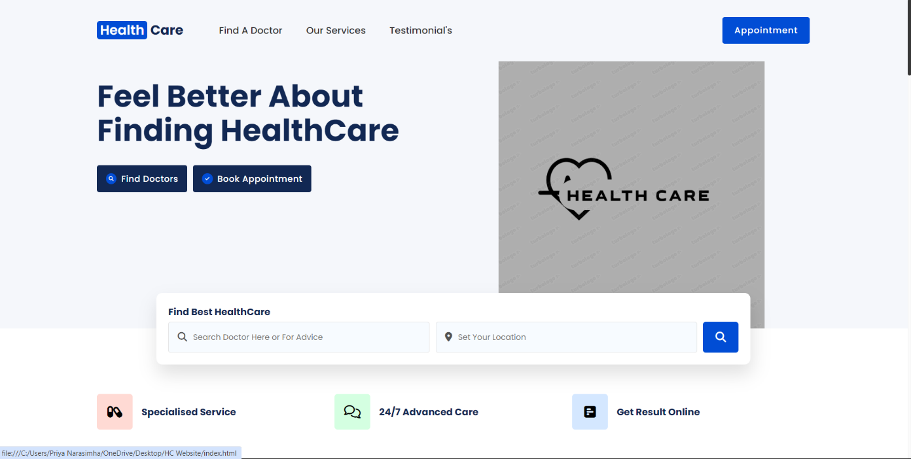

### Page 2



### Page 3:

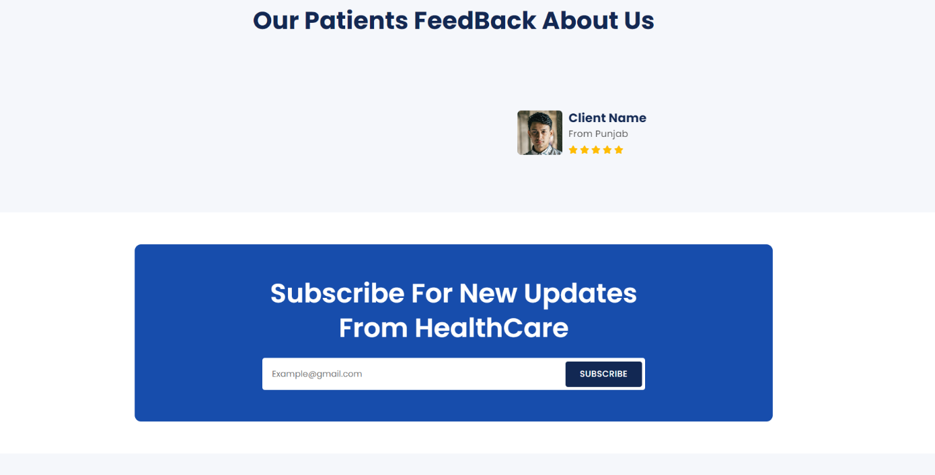

### Page 4:

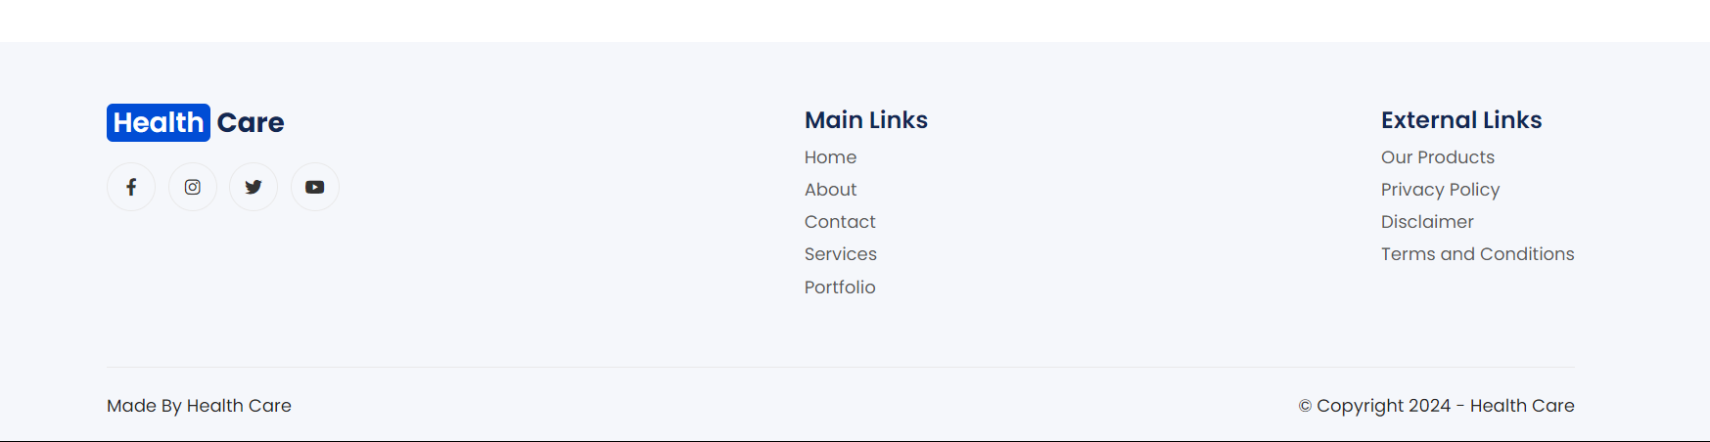

### Page 5:

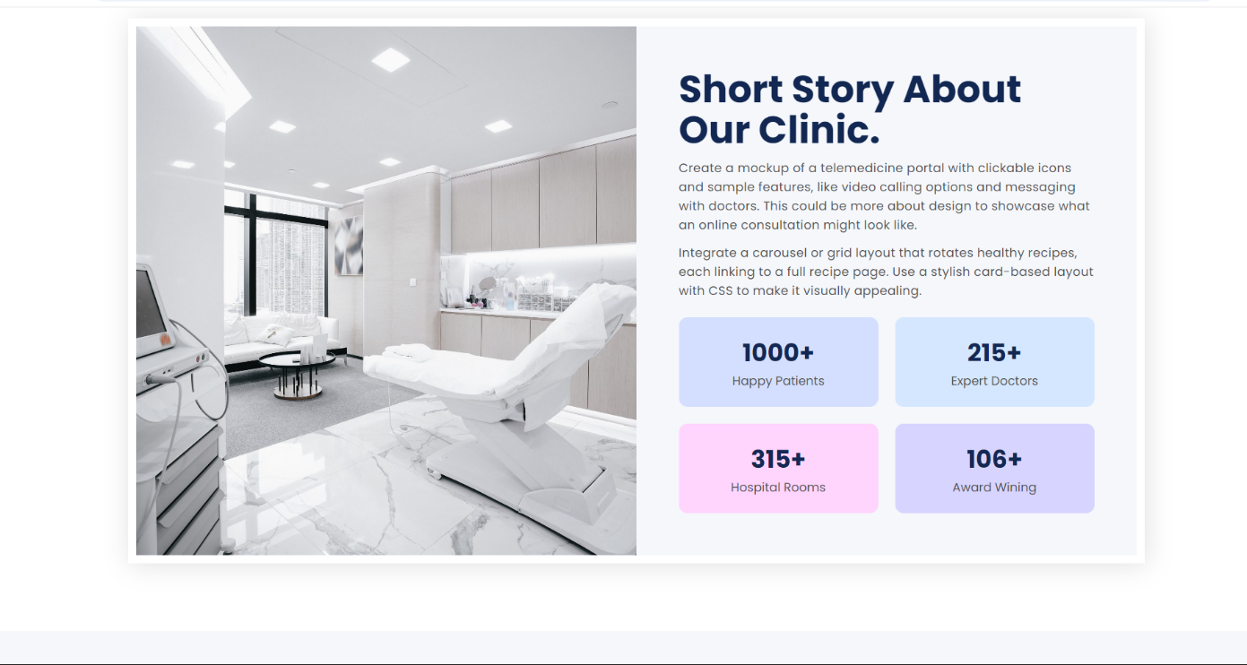

### Page 6:

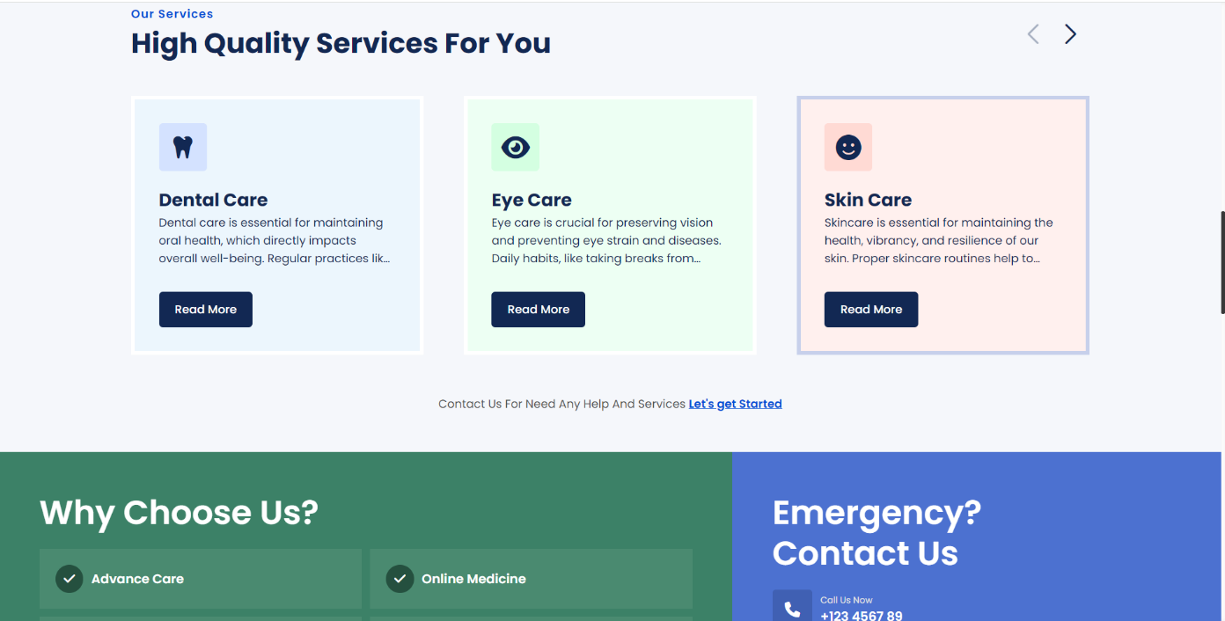

### Page 7:

### 

## List of Symbols, Abbreviations and Nomenclature

**Symbols and Abbreviations:**

1. **<!DOCTYPE html>**: Declaration that defines this document as an HTML5 document.
2. **<html>**: Root element that wraps all the content on the page.
3. **<head>**: Contains meta-information about the document, such as its title and links to stylesheets.
4. **<meta>**: Tag used to specify metadata about the HTML document (e.g., charset, viewport).
5. **<title>**: Sets the title of the document, which is displayed in the browser's title bar or tab.
6. **<link>**: Used to link external resources like stylesheets.
7. **<body>**: Contains the content of the HTML document that is visible to users.
8. **<header>**: Represents introductory content or navigational links.
9. **<nav>**: Defines a set of navigation links.
10. **<ul>**: Stands for "unordered list," used to create a list of items.
11. **<li>**: Stands for "list item," used within <ul> or <ol> to define each item.
12. **<strong>**: Indicates that the text is of strong importance, typically rendered in bold.
13. **<img>**: Tag used to embed images in the document.
14. **<footer>**: Represents the footer for a section or page, typically containing copyright information or links.
15. **©**: HTML entity representing the copyright symbol (©). **Nomenclature:**

* **CSS (Cascading Style Sheets)**: A stylesheet language used to describe the presentation of a document written in HTML or XML.
* **HTML (Hyper Text Markup Language)**: The standard markup language for creating web pages.
* **Viewport**: The user's visible area of a web page.
* **Metadata**: Data that provides information about other data, such as the character set or viewport settings in HTML.
* **Attributes**: Additional information provided in HTML tags, such as ‘**src’** for images or ‘**href’** for links.

## References

1. **MDN Web Docs** - Comprehensive documentation on web technologies.
2. **freeCodeCamp** - Interactive coding tutorials and exercises.
3. **Codecademy** - Interactive lessons on web development.
4. **Khan Academy** - Free courses on computer programming and web development.
5. **Coursera** - Courses from universities on web development topics.
6. **Udemy** - Wide range of paid and free courses on web development.
7. **HTML Dog** - Tutorials and references for HTML, CSS, and JavaScript.
8. **Tutorialspoint** - Tutorials on various programming languages and web technologies.
9. **GeeksforGeeks** - Tutorials, articles, and coding challenges on web development.
10. **CSS-Tricks** - Articles and guides focused on CSS and web development.

Project Done by:

K. Harish

K24AN

05